REVISED BLOOM’S TAXONOMY MEASURABLE VERBS
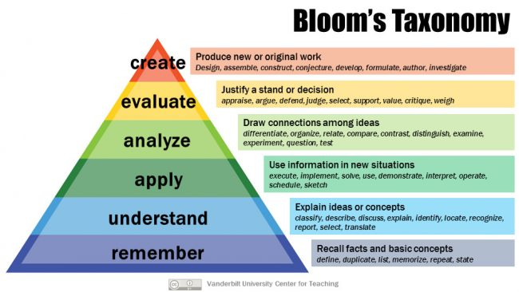
Remember | - List  - Name  - Recall  - Relate  - Repeat  - State  - Tell  - Underline | - Restate  - Match  - Cite  - Define  - Label  - Describe  - Show
Understand | - Compare  - Describe  - Discuss  - Explain  - Express  - Identify  - Recognize | - Restate  - Translate  - Classify  - Interpret  - Diagram  - Illustrate
Apply | - Apply  - Complete  - Construct  - Demonstrate  - Dramatize  - Employ  - Illustrate | - Interpret  - Operate  - Practice  - Schedule  - Sketch  - Use
Analyze | - Analyze  - Appraise  - Categorize  - Compare  - Contrast  - Debate  - Diagram | - Differentiate  - Distinguish  - Examine  - Experiment  - Inspect  - Inventory  - Question
Evaluate | - Appraise  - Argue  - Assess  - Choose  - Compare  - Conclude  - Estimate  - Evaluate  - Interpret | - Judge  - Justify  - Measure  - Rate  - Revise  - Score  - Select  - Support  - Value
Create | - Arrange  - Assemble  - Collect  - Combine  - Comply  - Compose  - Construct  - Create  - Design | - Devise  - Formulate  - Manage  - Organize  - Plan  - Prepare  - Propose  - Setup

