⁠ 

Blackboard Grades Integration
  - Importing Grades from Blackboard into Campus Connection

Grades Integration Overview
Grades Integration enables the instructor of record to import final grades from their Blackboard course directly into Campus Connection, eliminating the need for manual grade entry. This guide outlines the process for importing final grades.

Important Notes
- This process applies exclusively to final grades. Midterm grades cannot be imported at this time.
- After importing grades into Campus Connection, instructors must review and revise grades as needed before submitting them.
- For courses with multiple sections combined into a single Blackboard course, grades must be imported into Campus Connection separately for each section.

Step 1: Finalize Grades in Blackboard
- Review the Grading Schema. Ensure the grading schema used in Blackboard matches the letter grade schema required in Campus Connection.
- Review Final Grades in Blackboard. Confirm the accuracy of the final grades in Blackboard before beginning the import process.
  - In Blackboard Ultra courses, grades are imported using the Overall Grade column. This column must be set to show the letter grade.

  - In Blackboard Original courses, grades are imported using the CC Final Grade column. The primary display must be set to letter grade.
Note: After importing grades, you can still review and update them before submitting.

Step 2: Import Grades into Campus Connection
- Navigate to the Grade Roster. Go to Self-Service > Faculty Center > Grade Roster.
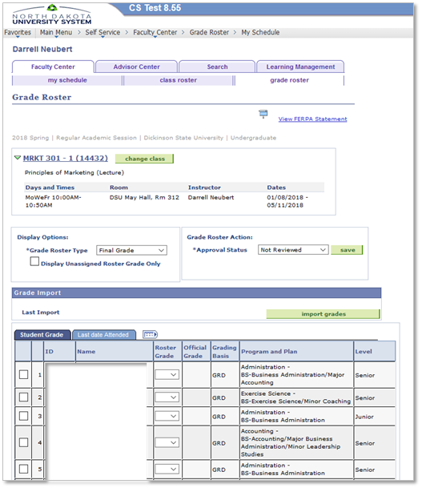
- Import Grades. Click the Import Grades button to transfer grades from Blackboard into Campus Connection.
For merged Blackboard courses (one Blackboard course containing multiple Campus Connection sections), each section must be imported separately.
Grades for the current section will populate correctly, while students from the other sections will appear in the Grade Import Error Log with the error: “Student does not exist on Roster.”
- Review and Adjust Grades. After importing grades, review the results.
  - To correct a grade, use the drop-down menu to select a new grade.
  - If the Grade Import Error Log link appears, click it to address errors. See Common Errors and Resolutions for guidance.
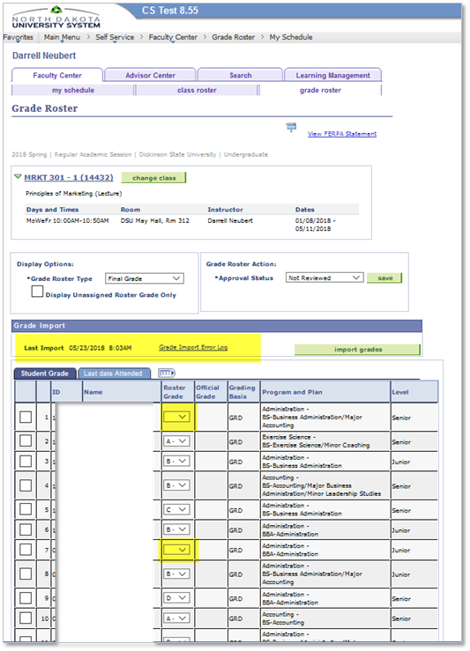
IMPORTANT: If the Grade Import Error Log link displays as shown here, you need to click it to review errors.
If necessary, instructors can override the imported grade by choosing the drop-down arrow and selecting a different grade.
- Repeat these steps for additional sections of the course as needed.

FN, UN, FNN, and UNN GRADES
When grading in Blackboard, remember to use FN, UN, FNN, UNN in the following situations:
FN, UN
Use these grades when a student stops attending class, and earned an F or U.
You will need to enter the last date of attendance in the Grade Roster in Campus Connection. The grade center in Blackboard shows the last date the student logged into the course.

FNN, UNN
Use these grades when a student never attended your class.
These grades are used by Financial Aid in determining if disbursed funds are required to be sent back.

Common Errors and Resolutions

Error: Student does not exist in LMS
This means the student(s) does not exist in Blackboard or no grades have been entered in Blackboard for the student(s).
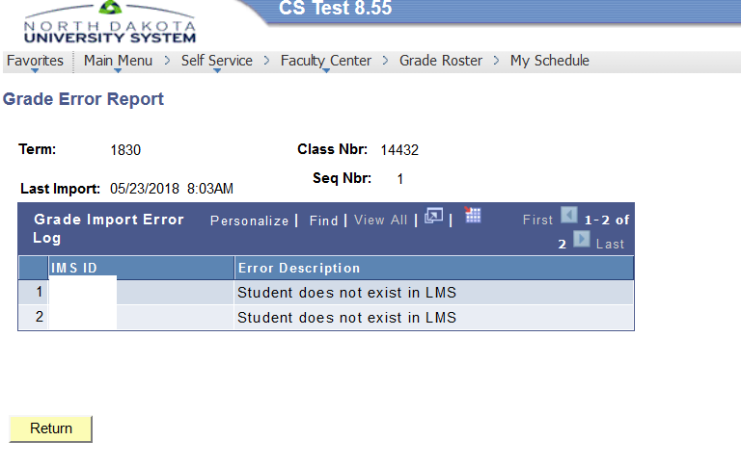
RESOLUTION: If the student(s) are in Blackboard, apply a grade in Blackboard and then re-import grades into Campus Connection. If the student(s) do not exist in Blackboard, manually enter the grades in the Grade Roster in Campus Connection.

Error: Student does not exist on Roster
This error occurs when a student is present in the Blackboard course but not enrolled in Campus Connection.
Possible Resolutions
- If your course has multiple sections merged in Blackboard, this error is expected for students not enrolled in the specific section you are working with.
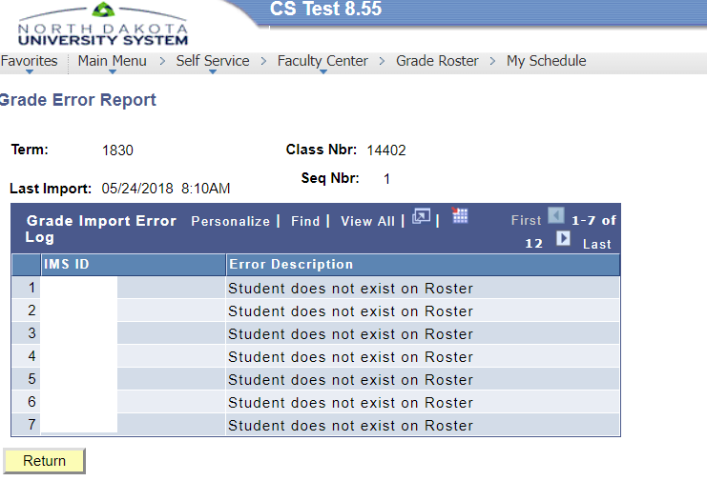
- If the error occurs for a student who should be enrolled in the section, please contact the Registrar’s Office for assistance in resolving the issue.

Error: The grade submitted is not a valid grade for the student
The grade entered in Blackboard is not a valid grade for this class in Campus Connection. Select the roster grade dropdown in Campus Solutions to see which grades are valid for this class.
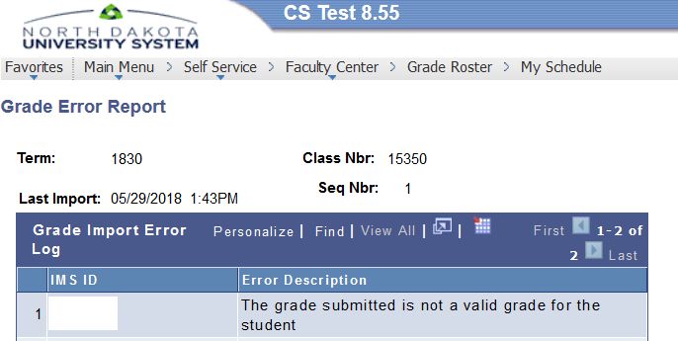
RESOLUTION: The best practice is to enter the valid grade in Blackboard, and then re-import the grades into Campus Connection. This ensures consistency between the grade in Blackboard and the grade in Campus Connection. In Blackboard, make sure the correct grade schema has been selected for the course.

Error: Unable to import grades
Most commonly the student has a W in Campus Connection, meaning the student dropped the course.
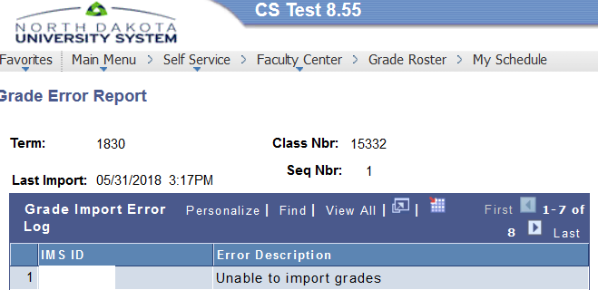
RESOLUTION: No action is needed.

Changing the Default External Grade Column - Blackboard Original Courses Only
If the default grade column has been deleted in your Blackboard Original course, another grade column can be used for importing, provided the following conditions are met:
- The column must be set as the External Grade Column.
- The primary display of the column must be set to letter grade. The letter grade schema used in Blackboard must match the letter grade schema required by your Registrar for that course.

Need Further Assistance?
Contact your campus Blackboard Administrator for more information.

