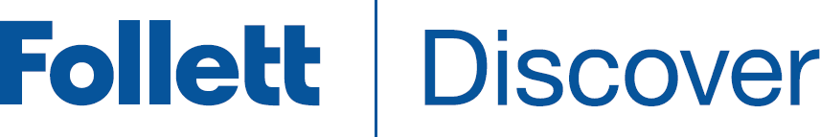

Concierge
Adopt On Behalf Of Faculty
Follett Discover is a powerful online tool that transforms the course materials discovery and adoption process for faculty, and helps students obtain, organize, and instantly access their required and recommended course materials from within your learning management system. The Follett Discover Concierge role is designed to work with the faculty experience and allow course material adoptions to be submitted by users on behalf of faculty members.
This quick reference guide provides instructions on how to quickly submit adoptions on behalf of faculty members for courses within your departments.

Getting Started—Follett Discover
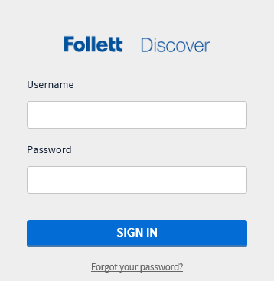
Tip: Forgot your password?
Click the Forgot your Password link below the login box.

To access your Follett Discover website:
- Access your institution’s Follett Discover site.
- Log in with your email address and password.
- The main dashboard is displayed.
Note: Contact your campus store manager if you do not have a concierge account or need to update your department access.

The main dashboard makes it easy to start submitting adoptions for the current term. Use the Department and Term selectors to view each assigned department or easily search for a particular course by course number.
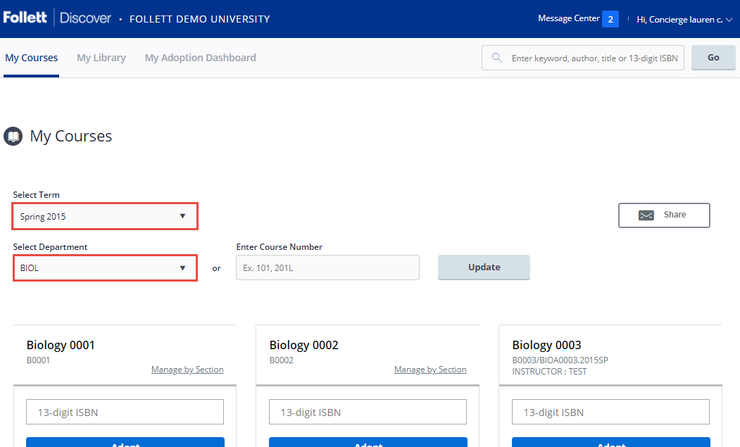

Submitting Adoptions
You can quickly submit adoptions by entering in the 13 digit ISBN for each course and click Adopt.
To search for specific materials, use the magnifying glass in the upper right corner of the screen at any time to search by title, author, ISBN, or keyword.
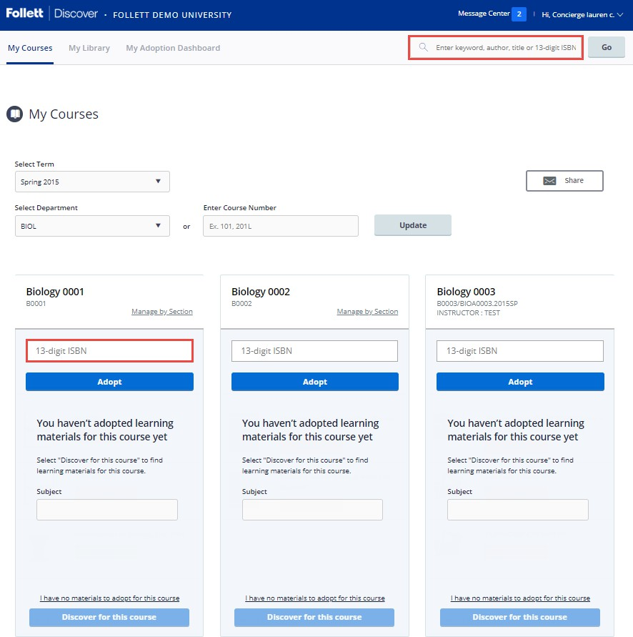

- Adopting supplies? Search by keyword and select the Supplies tab in the search results.
- Adoptions for each course are automatically adopted for all sections. To separate a course into individual sections, select Manage By Section.
Tip: If the course does not have any required materials, click the I have no items to adopt for this course link.

My Library
You can use the library to quickly adopt titles you have adopted previously. Import adopted materials easily for the departments you manage. Access your library from the My Library link on the main dashboard or the Copy button within your courses.
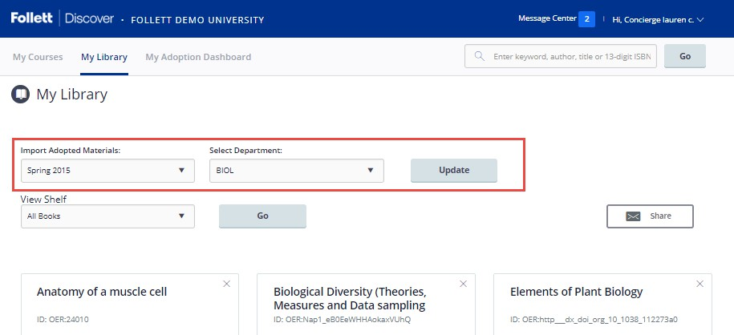
Tip: Create shelves to organize your library materials.
To adopt materials directly from your library
- Click the Copy button at the bottom of the page.
- Select all the materials you wish to adopt.
- Select the department and term.
- Select all the courses you want to adopt the materials for.
- Click the Adopt Materials button to submit.

Sharing Adopted Materials
Sharing the adopted materials with faculty (or for your own personal records) can be done from the My Courses page.
- Select your Term and Department.
- Check the Share Adopted Materials box.
- Check all courses you wish to share the adopted materials for.
- Enter in the email addresses of the recipients.
- Click the Send to Recipient(s) button to share the report.
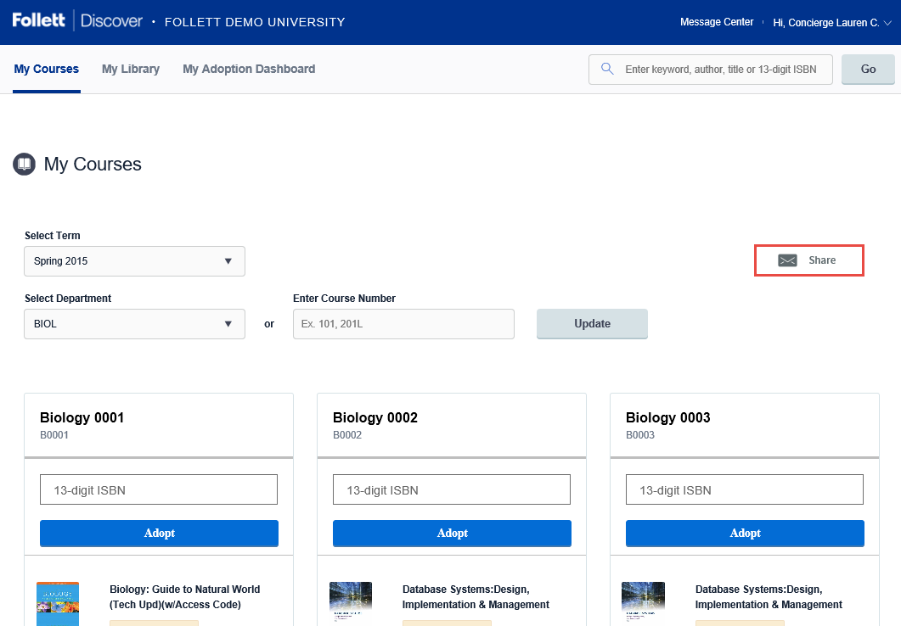

Adoption Dashboard Report
The Adoption Dashboard Report provides insight into your departments adoption compliance. View adoption status by campus, department, course and even drill down to the section. You can select to export the report to Excel or PDF.
- The Compliance Rate shows the percentage of completed course adoptions for your assigned departments.
- View the Adoption Compliance Trend to see adoption compliance rate over time for your campus.
Tip: Switch between campuses or terms in the upper right hand corner.

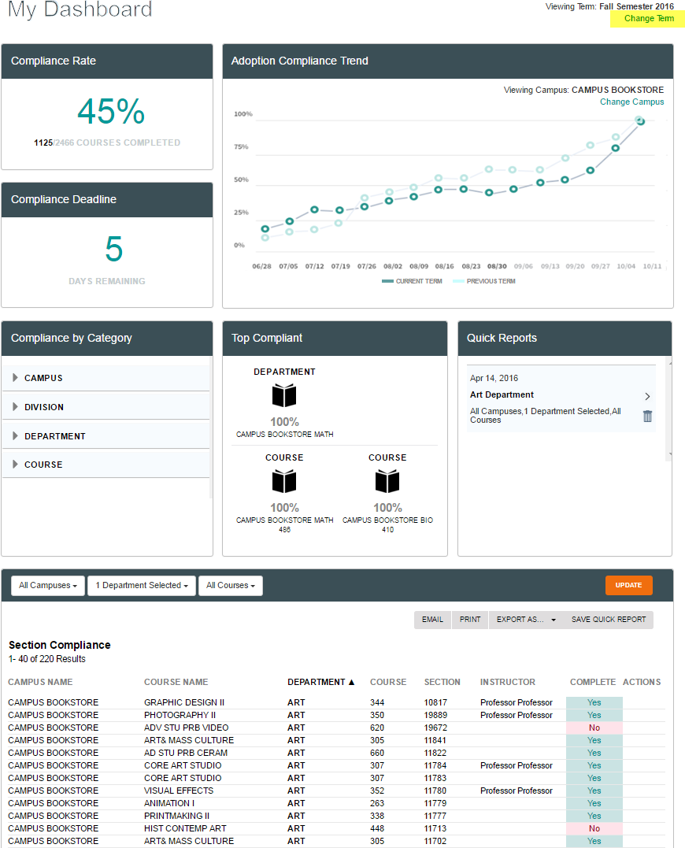
Note: The adoption compliance report only shows the departments that have
been assigned to you. Contact the campus store manager to request additional access.
View and save compliance reports.
- Filter results by Campus, Department, and Course.

To save the currently viewed report as a Quick Report:
- Select SAVE QUICK REPORT.
- Name the quick report.

