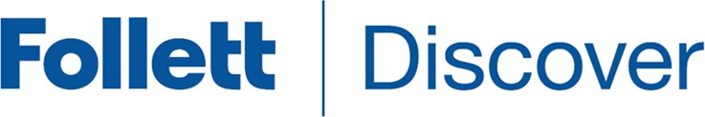

Faculty

Follett Discover is a powerful online tool that transforms the course materials discovery and adoption process for faculty and helps students obtain, organize, and instantly access their required and recommended course materials from within your learning management system.
The purpose of this document is to give an overview on how to use and access some of the features within Follett Discover. Watch the Follett Discover demo videos.

Getting Started – Follett Discover
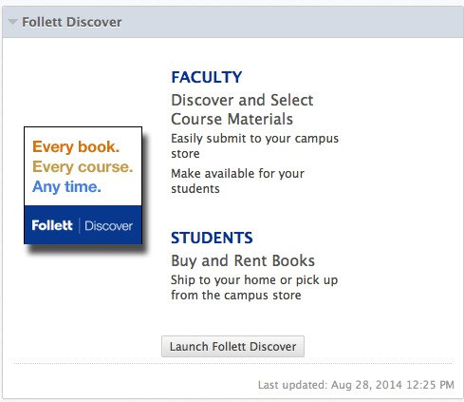
Follett Discover module within Blackboard.
To access Follett Discover:
- Log in to your Learning Management System.
- Look for the Follett Discover link or button to launch Follett Discover.

Upon launching Follett Discover, you are landed on the My Courses screen with your personalized courses for the upcoming term.

Submitting Adoptions
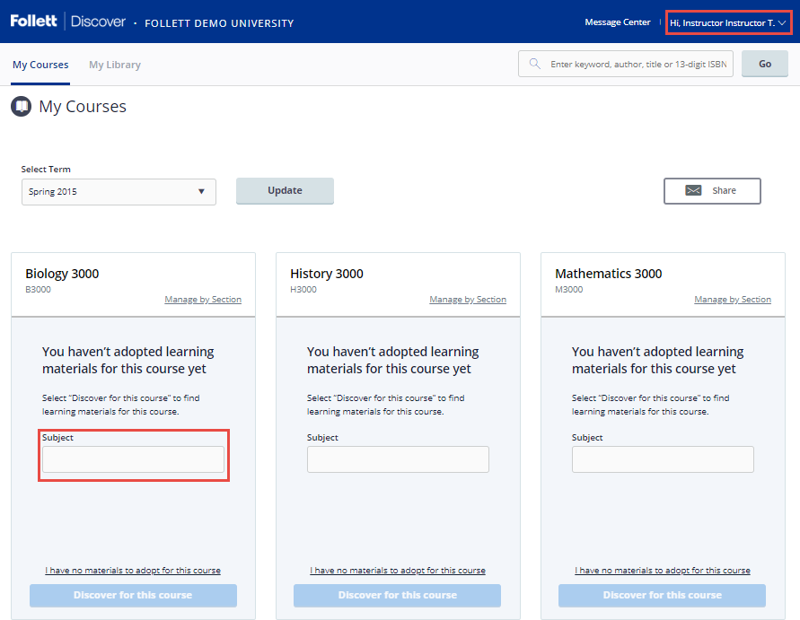
Discovering course materials is easy with Follett Discover. Just type in your Subject to start discovering new materials.
You can also use the global search in the upper right hand corner to find course materials & supplies by keyword, author, title or 13 digit ISBN.

- Select Term allows you to select between past terms, current terms, and future terms. If adoptions are open, you can start adopting for any future terms that are available here.
- Manage by Section allows you to submit and manage adoptions by individual section instead of at the course level.
- Selecting the course header allows you to manage your adoptions, discover materials, upload your own content, and leave a message for your students within each specific course.
- Share allows you to email a copy of your adopted materials.

Viewing Course Materials
The course material details page displays information including the description, table of contents, lowest price available to your students and availability options such as rental or digital.
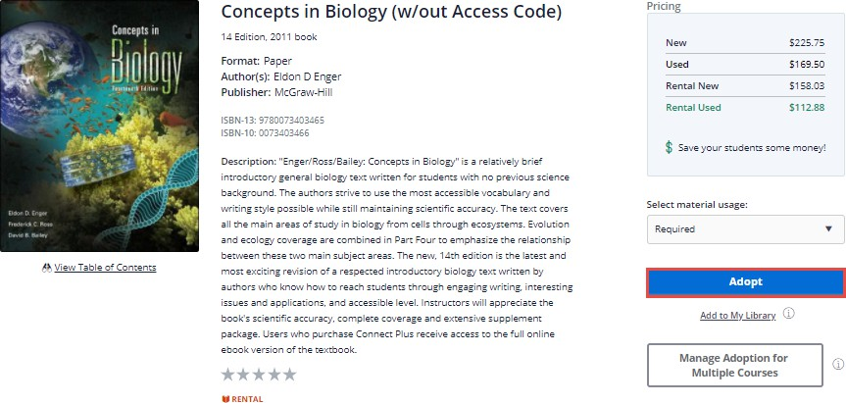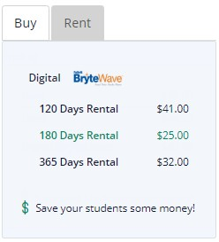
Scrolling down you will see neighboring institutions who have adopted this material, related items from this publisher, and materials that other instructors adopted.
To adopt a material:
- Select the material usage.
- Click Adopt to submit.

My Library
You can use the library to quickly adopt titles you have adopted previously. Access your library from the My Library link on the main dashboard or the Copy button at the bottom of your course homepage or from within your courses.
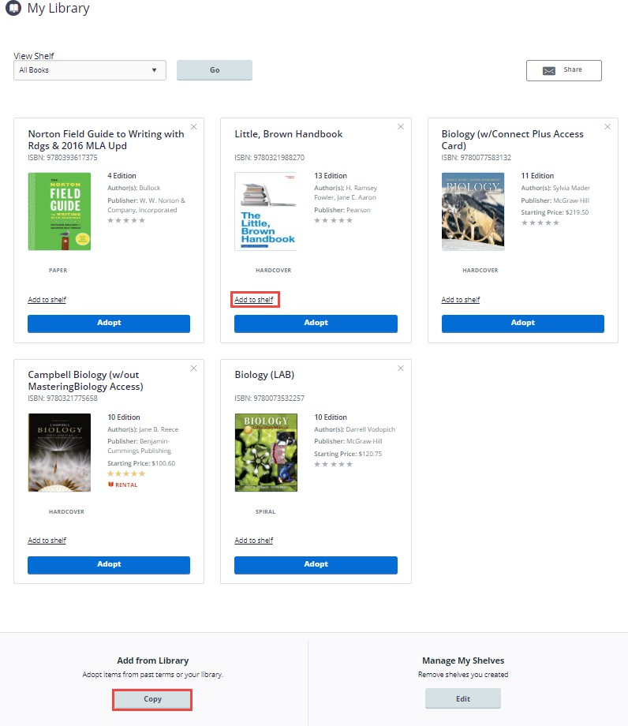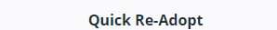
To adopt multiple materials from your library:

- Click the Copy button at the bottom of the page.
- Select all the materials you wish to adopt.
- Select the department and term.
- Select all the courses you want to adopt the materials for.
- Click the Adopt Materials button to submit.

Tip: Create shelves to organize your library by subject or topic.

Manage Course Adoptions
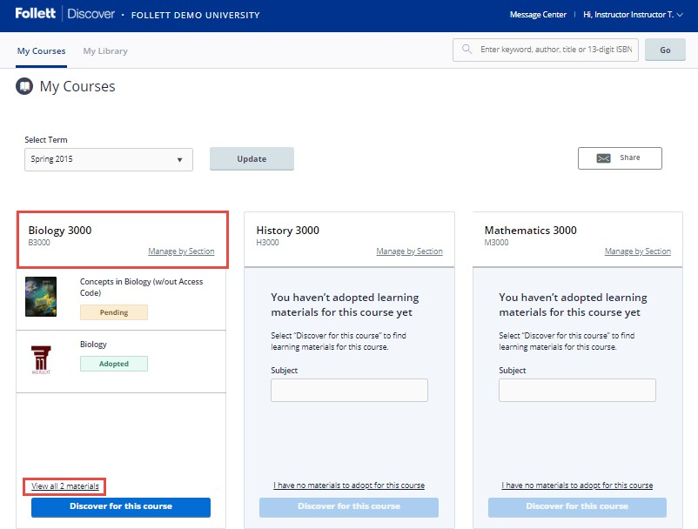
Manage a course by selecting the course banner or the View all Materials link from the My Courses page.
Within the course management screen, you can:
- Update the Discipline and Subject.
- View the status of your adopted materials.
- Remove adopted materials.
- Adopt items from your library.
- Create custom course packs.
- Continue discovering additional materials.
- Add instructions for your students.

