American Psychological Association (APA) 7 Format and Documentation

This handout covers the basics of APA formatting and the documentation of sources frequently used by students. For more complete information, refer to the Publication Manual of the American Psychological Association, 7th ed. The APA also provides tutorials and resources at APA Style website.

Formatting Your Paper

- Margins: One-inch margins on all sides of the page.
- Page Numbering: Number pages consecutively, beginning with the title page. Use your word-processing program to automatically insert page numbers in the upper right corner of the page.
- Title Page: The title page includes six elements: title, author byline, institutional affiliation, course number and name, instructor name, and assignment due date.
- Spacing: Double-space between all lines of the paper, including the title, headings, quotations, and references.
- Text: Begin the text on a new page. The title of the paper will be centered, bolded, and in title case at the top of the page. Text should be aligned left with a “ragged” right margin and paragraphs begin with a 0.5 in. indentation.

Example #1: APA Student Title Page (screenshot from Microsoft Word APA paper format)

: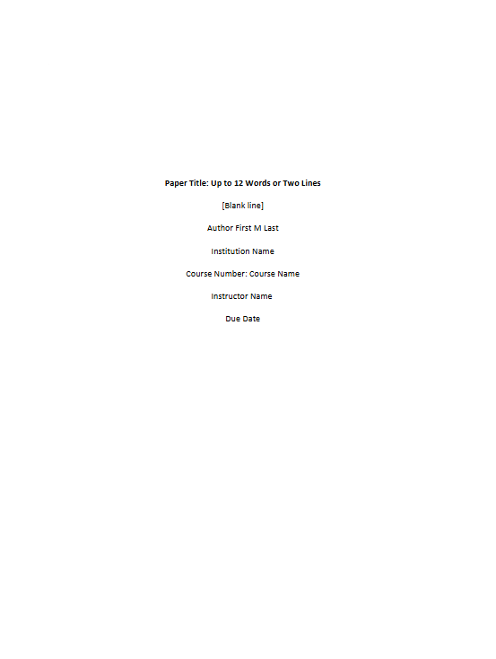

For full description of Example #1 in the Appendix, please select the link.

Headers

Level | Format
1 | Centered, Bold, Title Case Heading  Text begins as a new paragraph.
2 | Flush Left, Bold, Title Case Heading  Text begins as a new paragraph.
3 | Flush Left, Bold Italic, Title Case Heading  Text begins as a new paragraph.
4 | Indented, Bold, Title Case Heading, Ending with a Period. Text begins on the same line and continues as a regular paragraph.
5 | Indented, Bold Italic, Title Case Heading, Ending with a Period. Text begins on the same line and continues as a regular paragraph.

Example #2: APA Paper and Heading Formatting (screenshot from Microsoft Word APA paper format)

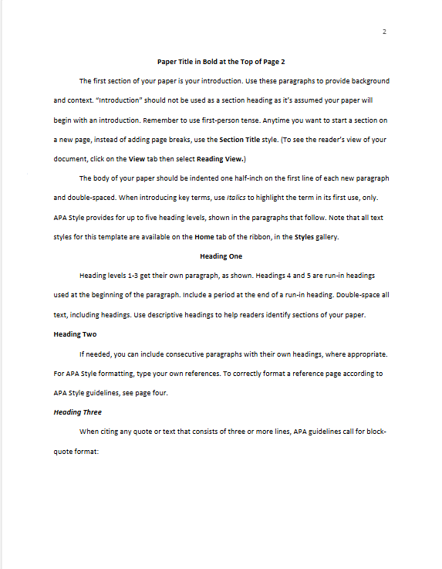

For full description of Example #2 in the Appendix, please select the link.

Creating the Reference List

- The reference list starts on a new page and has a page number.
- Continue double spacing.
- Reference list citations should be formatted in hanging indent style.
- Arrange entries in alphabetical order.
- Do not abbreviate journal titles.
- Provide surnames and initials for up to and including 20 authors. When there are two to twenty authors, use an ampersand before the final author’s name. (ex. Author, A.A., Author B. B., & Author, C.C.)
- When there are 21 or more authors include the first 19 authors’ names insert and ellipses (but no ampersand) and then add the final author’s name. (Example on page 317 in the APA 7)
- Title of article in sentence case (except for pronouns that would be capitalized or the word immediately after a colon in the title.)
- Only reference sources cited in the body of the document.
- Do not provide retrieval dates.
- Academic or professional credentials (PhD, MD, JD) are not listed.

Example #3: APA Reference Page

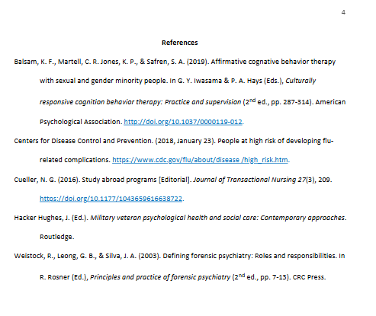

For full description in Example #3 of the Appendix, please select the link.

Sample Reference List Entries

Periodicals

Journal article with a DOI
Author, A.A., & Author, B.B. (Year). Title of article. Title of periodical in italic sentence case, vol.(issue), pages. DOI

McCauley, S. M., & Christiansen, M. H. (2019). Language learning as language use: A cross-linguistic model of child language development. Psychological Review, 126(1), 1-51. https://doi.org/10.1037/rev0000126

Parenthetical citation: (McCauley & Christiansen, 2019)
Narrative citation: McCauley and Christiansen (2019)

Books and Reference Works

Authored book with a DOI
Author, A.A., & Author, B.B. (Year). Title of book in italic sentence case *. Publisher. DOI
*If there is additional information (audiobook, editor’s name, translator’s name, narrator’s name) it will go here.
For example: Title of book (2nd ed., Vol. 4).
Title of book [Audiobook].
Title of book (E. E. Editor, Ed.).
Title of book (T. Translator, Trans.; N. Narrator, Narr.).

Brown, L. S. (2018). Feminist therapy (2nd ed.). American Psychological Association. https://doi.org/10.1037/0000092-000

Parenthetical citation: (Brown, 2018)
Narrative citation: Brown (2016)

Edited Book Chapters and Entries in Reference Works Chapter in an edited book with a DOI
Author, A.A., & Author, B.B. (Year). Chapter title. In E. E. Editor (Ed.), Title of book in italic sentence case (edition # ed., Vol. #, pp. #-#). Publisher name. DOI

Balsam, K. F., Martell, C. R., Jones, K. P., & Safren, S. A. (2019). Affirmative cognitive behavior therapy with sexual and gender minority people. In G. Y. Iwasama & P. A. Hays (Eds.), Culturally responsive cognitive behavior therapy: Practice and supervision (2nd ed., pp. 287-314). American Psychological Association. https://doi.org/10.1037/0000119-012

Parenthetical citation: (Balsam et al., 2019)
Narrative citation: Balsam et al. (2019)

Webpages and Websites

Webpage on a website with an individual author
Author, A. A. (Year). Title of work in italic sentence case. Site Name. URL.

Martin Lillie, C. M. (2016, December 29). Be kind to yourself: How self-compassion can improve your resiliency.
Mayo Clinic. https://www.mayoclinic.org/healthy-lifestyle/adult-health/in-depth/self-compassion-can- improve-your-resiliency/art-20267193

Parenthetical citation: (Martin Lillie, 2016)
Narrative citation: Martin Lillie (2016)

Basic In-Text Citations

Author’s name appears in the sentence (narrative citation):
Koehler (2016) noted the dangers of falsely balanced news coverage.

Author’s name appears in the sentence (parenthetical citation):
Falsely balanced news coverage can distort the public’s perception of expert consensus on an issue (Koehler, 2016).

Block quotes:
If the quotation is longer than 40 words, start a block quotation on a new line and indent it one tab space from the left margin. Do not indent the right margin.

Wilson (1997) comments:
The concept of a life force was central to medical practice in many ancient cultures. Qi is called “Chi” in China, “Ki” in Japan, “Prana” in India, “The Great Spirit” in Native America, “Num” in the plateau region of Africa, and “Lapa’au” in the Kahuna shamanic tradition of Hawaii. (p. 6)

Two authors:
If a source has two authors, use an ampersand between last names in the parenthetical reference. (Dabul & Michaels, 1996, p. 12)

More than two authors:
If a source has more than two authors, include the name of the first author followed by “et al.” in every citation, even the first time, unless it would be ambiguous.
(Huang et al., 1992, p. 10)

More than one source:
If you cite more than one source in your parenthetical reference, list citations alphabetically and separate them with semicolons.
(Forsythe, 1997; Polyani & Freeman, 1998; Singh, 2000)

Missing information:
If a source has no identified author, cite the first few words of the reference list entry. If a source has no page numbers, but does provide paragraph numbers, include the paragraph number that the direct quote comes from instead.
(“Four Homes Destroyed,” 2009, para. 1)

Appendix

Example #1: APA Student Title Page

Title Page begins by pressing the Enter key five times. Title page information is centered and double spaced on the page.

Paper Title is Bold and Up to 12 Words or Two Line in Title Case
This line remains blank
Author’s First Name Middle Initial Last Name
Student Affiliation includes the Name of the Department comma Name of the Institution
COURSE CODE and Number colon Course Name – Course Code is in all capital letters and Course Name is in Title Case
Instructor’s Name
Due Date
APA provides the following Sample Student Title Page:
Nurturing the Nurses: Reducing Compassion Fatigue Through Resilience Training

Oliver B. Lee
Department of Family and Community Health, University of Pennsylvania
NURS 101: The Nature of Nursing Practice
Dr. Priya C. Agarwal
March 16, 2020

Return to Example #1: APA Title Page

Example #2: APA Paper Formatting

Microsoft Word provides a narrative breakdown of how an APA Paper is Formatted in APA format. Below is an expanded and modified version of Microsoft Word’s description in APA Formatting.

Paper Title in Bold and Centered at the Top of Page 2 in Title Case
The first section of your paper is your introduction. Use these paragraphs to provide background and context. A subhead that identifies that “Introduction” section should not be used as it’s assumed your paper will begin with an introduction.
The body of your paper should be left aligned, the first line of each new paragraph indicated one half inch, and double spaced. APA Style provides for up to five heading levels, shown in the paragraphs that follow.
Heading One is Centered and Bold
Heading levels one through three get their own paragraph(s). Headings four and five are run-in headings used at the beginning of the paragraph. Include a period at the end of a run-in heading. Double-space all text, including headings.
Heading Two is Left Aligned and Bold
If needed, you can include consecutive paragraphs with their own headings, where appropriate.
Heading Three is Left Aligned, Bold, and Italic
When citing any quote or text that consists of 40 words or more, APA guidelines call for block-quote format:
Create a new paragraph to begin the block-quote. Double-space each line of the text, as you have done with headings, section labels, and paragraphs of paraphrased text. To correctly format a block-quote, indent each line of the text to one-half inch. Remember to always cite your source. (Last Name, Year)
Last Name (Year) citations can be used when writing a paper in narrative form; parenthetical citations are also appropriate (Last Name, Year).
Heading Four. Heading four is indented, bold, and in Title Case followed by a period. When using headings, don’t skip levels. If you need a heading level three, four, or five with no text following it before the next heading, just add a period at the end of the heading and start a new paragraph for the subheading and its text.
Heading Five. Heading five is indented, bold, italic, and in Title Case followed by a period. It is unlikely that papers will contain heading levels four and five. Most papers only go up to heading level three.

Return to Example #2: APA Paper and Heading Formatting

Example #3: APA Reference Page

The reference page should be double-spaced and identified using Heading Level 1 that says “References.”

References
Balsam, K. F., Martell, C. R., Jones, K. P., & Safren, S. A. (2019). Affirmative cognitive behavior therapy with sexual and gender minority people. In G. Y. Iwasama & P. A. Hays (Eds.), Culturally responsive cognition behavior therapy: Practice and supervision (2nd ed., pp. 287-314). American Psychological Association. http://doi.org/10.1037/0000119-012.
Centers for Disease Control and Prevention. (2018, January 23). People at high risk of developing flu-related complications. http://www.cdc.gov/flu/about/disease/high_risk.htm.
Cueller, N. G. (2016). Study abroad programs [Editorial]. Journal of Transactional Nursing 27(3), 209. https://doi.org/10.104359616638722.
Hacker Hughes, J. (Ed.). Military veteran psychological health and social care: Contemporary approaches. Routledge.
Weistock, R., Leong, G. B., & Silva, J. A. (2003). Defining forensic psychiatry: Roles and responsibilities. In R. Rosner (Ed.), Principles and practice of forensic psychiatry (2nd ed., pp. 7-13). CRC Press.

Return to Example #3: APA Reference Page

