Modern Language Association (MLA) 9th Edition Format and Documentation
This handout covers the most common elements of MLA 9 formatting and documentation. For further information, consult the MLA Manual, 9th edition, or visit the MLA website.

Formatting Your Paper
(see sections 1.1-1.7 in MLA 9)
- Margins: All margins (top, bottom, and sides) should be set at 1 inch, with .5 inches between the page number and top margin.
- Typeface and Font: An easily readable typeface, such as Times New Roman (TNR) and anywhere between 11- and 13-point font (unless your instructor specifies a typeface and/or font).
- Page Numbering: Provide the page number flush right in the running head preceded by your last name by selecting insert>page numbers. If a project has several authors and all authors’ surnames do not fit in a running head, include only the page number (the same font and typeface as the paper).
- Spacing: Unless otherwise indicated, the entire document should be double-spaced (including the Works Cited page). Adjust Microsoft Word’s default line spacing: Home>Paragraph>Line Spacing Options>Spacing>After>0 pt.
- Headings and Subheadings: Subheadings are flush with the left margin. Each heading level should appear in the same appropriate style and size (level styles below). Avoid using all capital letters for headings or numbers and letters to designate headings unless doing so is conventional in the discipline you’re working in. No heading level should have only one occurrence (exceptions are the paper or chapter title, headings for notes, and works cited).
Heading Level 1 Heading Level 2 Heading Level 3
- Title Page: A title page is only required for group authored papers/projects (unless your instructor asks for a separate title page). Instead, the first page of the paper should begin with four double-spaced lines flush to the left margin that indicate: your name, the name(s) of the course instructor(s), the name and number of the course, and the date (in this order). The title of the paper should be on a separate line, centered and in Title Case (see sample below).

Example #1: MLA Paper Formatting
(screenshot modified from Microsoft Word MLA 9 paper format)
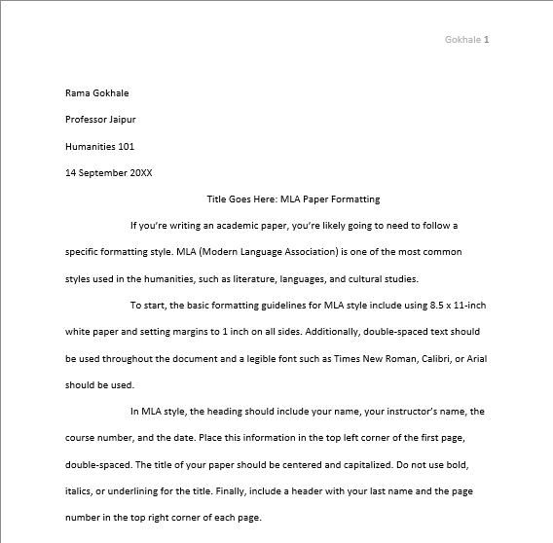

For full description of Example #1 in the Appendix, please select the link.

Creating the Works Cited Page
(see sections 1.6, 5.123-5.132)
- Page Numbering: Continue the page numbering from the main body of your paper.
- Title: “Works Cited” should be centered and one inch from the top of the page. If the list contains only one entry, make the heading “Work Cited”. Put a double-space between the heading and the first entry.
- Spacing: The Works Cited page should also be double spaced.
- Indenting: The lines of a citation that need to be indented are all the lines following the first line of a multiple line entry (see sample below). To indent all but the first line of a citation go to Home>paragraph>Line Spacing Options>Special: Hanging.
- Organization: Sources should be listed alphabetically by the author’s last name. If there is no author, use the first word in the title of the source other than A, An, or The (see sample below).
- Last name first: All sources, if they have an author, should be listed last name first followed by a comma and then the author’s first name (see sample below).

Example #2: Works Cited Page
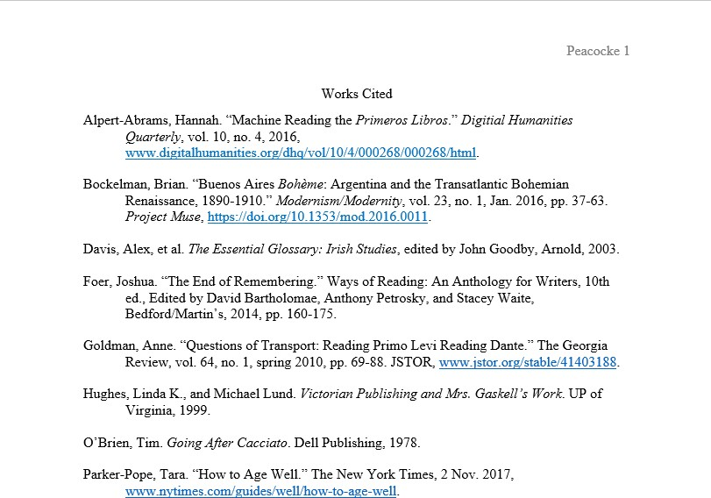

For full description of Example #2 in the Appendix, please select the link.

Sample of Most Common Works Cited Page Entries
(see sections 5.1-5.122, Appendix 2)

An Article in Scholarly Journal:
Database Journal with a DOI
Author’s Lastname, Firstname. “Title of Article in Quotation Marks.” Journal Title in Italics, volume number, issue number, Month or season Year of Publication, page numbers. Database Title in Italics, DOI.

Bockelman, Brian. “Buenos Aires Bohème: Argentina and the Transatlantic Bohemian Renaissance, 1890-1910.” Modernism/Modernity, vol. 23, no. 1, Jan. 2016, pp. 37-63. Project Muse, https://doi.org/10.1353/mod.2016.0011.
Database Journal with a Permalink
Author’s Lastname, Firstname. “Title of Article in Quotation Marks.” Journal Title in Italics, volume number, issue number, Month or season Year of Publication, page numbers. Database Title in Italics, Permalink.

Goldman, Anne. “Questions of Transport: Reading Primo Levi Reading Dante.” The Georgia Review, vol. 64, no. 1, spring 2010, pp. 69-88. JSTOR, www.jstor.org/stable/41403188.
Online Journal
Author’s Lastname, Firstname. “Title of Article in Quotation Marks.” Journal Title in Italics, volume number, issue number, Month or season Year of Publication, URL.

Alpert-Abrams, Hannah. “Machine Reading the Primeros Libros.” Digitial Humanities Quarterly, vol. 10, no. 4, 2016, www.digitalhumanities.org/dhq/vol/10/4/000268/000268/html.

Work in an Anthology or Compliation or a Chapter in and Edited Collection
Author’s Lastname, Firstname. “Title of Work in Quotation Marks,” Anthology Title in Italics, # of ed., edited by Editor’s Firstname Lastname, Publisher, Year of Publication, page numbers.

Foer, Joshua. “The End of Remembering.” Ways of Reading: An Anthology for Writers, 10th ed., Edited by David Bartholomae, Anthony Petrosky, and Stacey Waite, Bedford/Martin’s, 2014, pp. 160-175.

A Book by a Single Author
Author’s Lastname, Firstname. Book Title in Italics. Publisher, Year of publication/Copyright date.

O’Brien, Tim. Going After Cacciato. Dell Publishing, 1978.

Book by Two or More Authors
2 Authors
Author 1’s Lastname, Firstname, and Author 2’s Firstname Lastname. Title of Book in Italics. Publisher, Year of publication. Hughes, Linda K., and Michael Lund. Victorian Publishing and Mrs. Gaskell’s Work. UP of Virginia, 1999.
3+ Authors
Author 1’s Lastname, Firstname, et al. Book Title in Italics. Publisher, Year of publication.

Davis, Alex, et al. The Essential Glossary: Irish Studies, edited by John Goodby, Arnold, 2003.

News Publications
Published Online, without Page Numbers (see section 5.87).

Author’s Lastname, Firstname. “Title Article in Quotation Marks.” Web Site Title in Italics, Day Month Year of publication, URL or DOI

Parker-Pope, Tara. “How to Age Well.” The New York Times, 2 Nov. 2017, www.nytimes.com/guides/well/how-to- age-well.

Most Common In-text Citations
(see sections 6.1-6.82)

Author’s name appears in the sentence (Narrative):
In “Hunger as Ideology,” Susan Bordo claims that women are inundated with advertisements in which “food is constructed as a sexual object of desire and eating is legitimated as much more than a purely nutritive activity” (150).

Author’s name does not appear in the sentence (Parenthetical):
We demand images of youth because “sagging flesh is almost the ultimate signifier of decay and disorder” (Bordo 176).

Block quotes:
When a quotation is more than four lines, set it off as a block from the main text, indent it half an inch from the left margin, and do not add quotation marks that are not already present in the quote. End the quote with a period, then cite the page number in parentheticals after the period.

Graff and Birkenstein explain how some writers do not summarize effectively:
Many writers shy away from summarizing—perhaps because they don’t want to take the trouble to go back to the text in question and wrestle with what it says, or because they fear that devoting too much time to other people’s ideas will take away from their own. When assigned to write a response to an article, such writers might offer their own views on the article topic while hardly mentioning what the article itself argues or says. At the opposite extreme are those who do nothing but summarize. Lacking confidence, perhaps, in their own ideas, these writers so overload their texts with summaries of others’ ideas that their own voice gets lost. And since these summaries are not animated by the writers’ own interests, they often read like mere lists of the things that X thinks or Y says—with no clear focus. (30)

Two Authors:
Narrative: Mandy Suhr-Sytsma and Shan-Estelle Brown “argue that other writing centers can also use these lists as a heuristic for fostering productive dialogue about language, oppression, and resistance” (509).

Parentthetical: In the end of The Gold Rush, the main character George was able to find his wife even though she was swept away by the current (Benson and Mumford 26).

Three or more authors:
If a source has three or more authors, use the last name of the first author followed by “et al.”:

Narrative: Corinne Agostinelli et al. notes that “peer tutoring in an interaction between human beings, each with their own ideas and experiences” (34).

Parenthetical: We are told that “The earliest surviving architectural forms in Ireland are the remains of ring forts” (Davis et al. 13).

No Identified Author:
Narrative: Reading at Risk: A Survey of Literary Reading in America notes that despite an apparent decline in reading during the same period, “the number of people doing creative writing—of any genre, not exclusively literary works— increased substantially between 1982 and 2002” (3).

Parenthetical: Despite an apparent decline in reading during the same period, “the number of people doing creative writing—of any genre, not exclusively literary works—increased substantially between 1982 and 2002” (Reading 3).

References
MLA. MLA Handbook, 9th ed., The Modern Language Association of America, 2021.

Appendix

Example #1: MLA Paper formatting

Microsoft Word provides a narrative breakdown of how an MLA 9 paper is formatted in MLA format. Below is a modified version of Microsoft Word’s description in MLA formatting.

Gokhale 1

Rama Gokhale
Professor Jaipur
Humanities 101
14 September 2025
Title Goes Here: MLA Paper Formatting
If you’re writing an academic paper, you’re likely going to need to follow a specific formatting style. MLA (Modern Language Association) is one of the most common styles used in the humanities, such as literature, languages, and cultural studies.
To start, the basic formatting guidelines for MLA style include using 8.5 x 11-inch white paper and setting margins to 1 inch on all sides. Additionally, double-spaced text should be used throughout the document and a legible font such as Times New Roman, Calibri, or Arial should be used.
In MLA style, the heading should include your name, your instructor’s name, the course number, and the date. Place this information in the top left corner of the first page, double-spaced. The title of your paper should be centered and capitalized. Do not use bold, italics, or underlining for the title. Finally, include a header with your last name and the page number in the top right corner of each page.

Return to Example #1: MLA Paper formatting

Example #2: Works Cited page
Peacocke 1

Works Cited
Alpert-Abrams, Hannah. “Machine Reading the Primeros Libros.” Digital Humanities Quarterly, vol. 10, no. 4, 2016, www.digitalhumanities.org/dhq/vol/10/4/000268/000268/html.
Bockelman, Brian. “Buenos Aires Bohème: Argentina and the Transatlantic Bohemian Renaissance, 1890-1910.” Modernism/Modernity, vol. 23, no. 1, Jan. 2016, pp. 37-63. Project Muse, https://doi.org/10.1353/mod.2016.0011.
Davis, Alex, et al. The Essential Glossary: Irish Studies, edited by John Goodby, Arnold, 2003.
Foer, Joshua. “The End of Remembering.” Ways of Reading: An Anthology for Writers, 10th ed., edited by David Bartholomae, Anthony Petrosky, and Stacey Waite, Bedford/Martin’s, 2014, pp. 160-175.
Goldman, Anne. “Questions of Transport: Reading Primo Levi Reading Dante.” The Georgia Review, vol. 64, no. 1, spring 2010, pp. 69-88. JSTOR, www.jstor.org/stable/41403188.
Hughes, Linda K., and Michael Lund. Victorian Publishing and Mrs. Gaskell’s Work. UP of Virginia, 1999.
O’Brien, Tim. Going After Cacciato. Dell Publishing, 1978.
Parker-Pope, Tara. “How to Age Well.” The New York Times, 2 Nov. 2017, www.nytimes.com/guides/well/how-to-age-well.
Return to Example #2: Works Cited page

