Page 2 – Revision Process for Faculty
The following guide details the revision process for a Page 2 that has completed initial approvals. For information on revisions before the approval process has been completed, please see “Page 2 – Data Entry for Faculty.”
Updated: December 8, 2025

A separate workflow is required for revisions to a Page 2 after the initial approval process has been completed. These workflows will occur on a monthly basis.
- Revision workflows will be requested by your chair. To begin the process, speak with your chair about your anticipated revisions. Log into Faculty Success and navigate to My Profile. Scroll down to Page 2 [Future Goals].

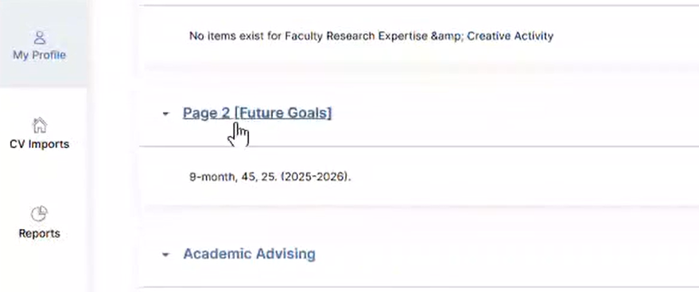
- Find your respective Page 2 and click the Edit icon.
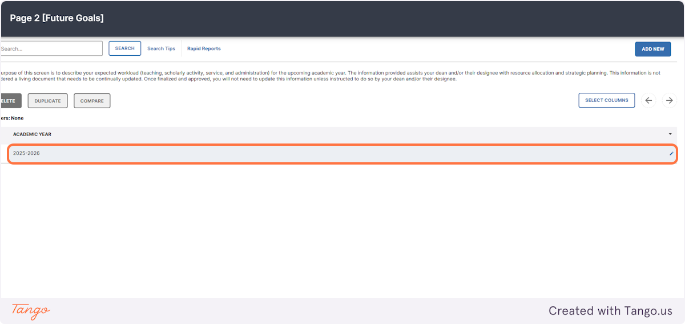
Do not click on the Duplicate option. This creates a separate Page 2. The Duplicate function is intended for creating a Page 2 for a future year that closely aligns with a previous year. For example, if my 2026-2027 Page 2 is very similar to my 2025-2026 Page 2, I may duplicate the older Page 2 and make minor changes for the new year.

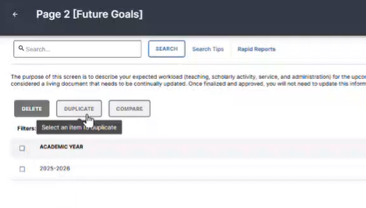
- Make the appropriate changes and select Save at the bottom of the screen. Inform your chair that you are ready for the workflow to be initiated.

- The revision workflow is initiated on the first Monday of each month (barring a holiday). You will receive an email to approve your Page 2 within 24 hours of the workflow being initiated.

- Once you receive your approval email, log into Faculty Success. Review the new PDF.

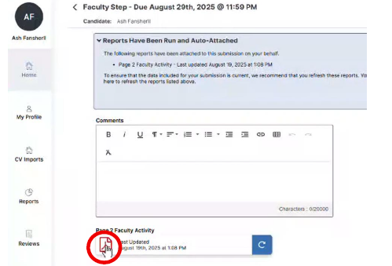
If the PDF does not reflect your changes, click the Refresh icon, then review again.
- When you are satisfied with the Page 2, go to Actions, then Submit to Department Chair. You have one week from the workflow initiation to approve your Page 2. If it is not approved during this time, the workflow will need to be rerun the following month.
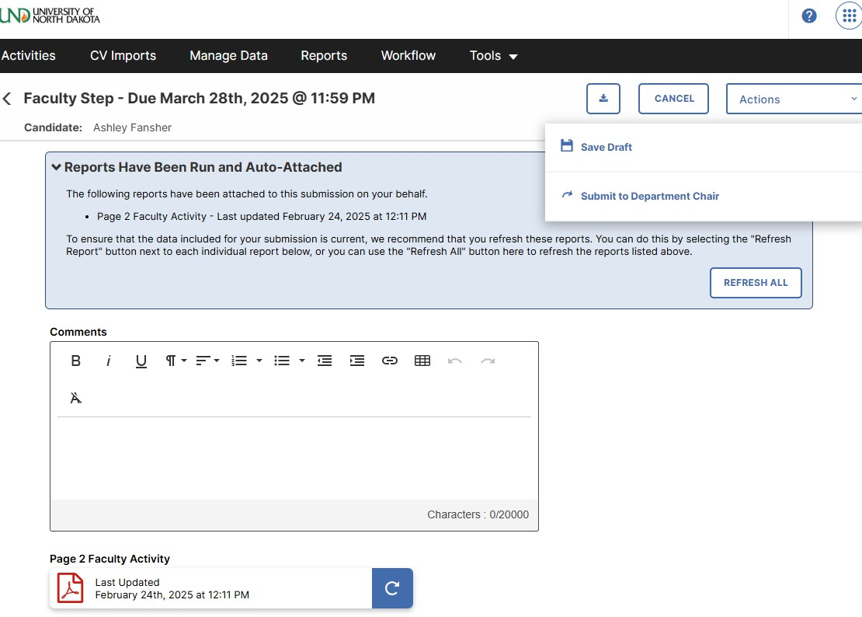

- The chair will approve or reject the Page 2. If the chair approves the Page 2, you will not receive a notification.

To check the status of your Page 2, log into Faculty Success and click Reviews. Under Current Step, you can see where your Page 2 is in the process. “Completed” indicates that both the chair and dean have approved your Page 2.

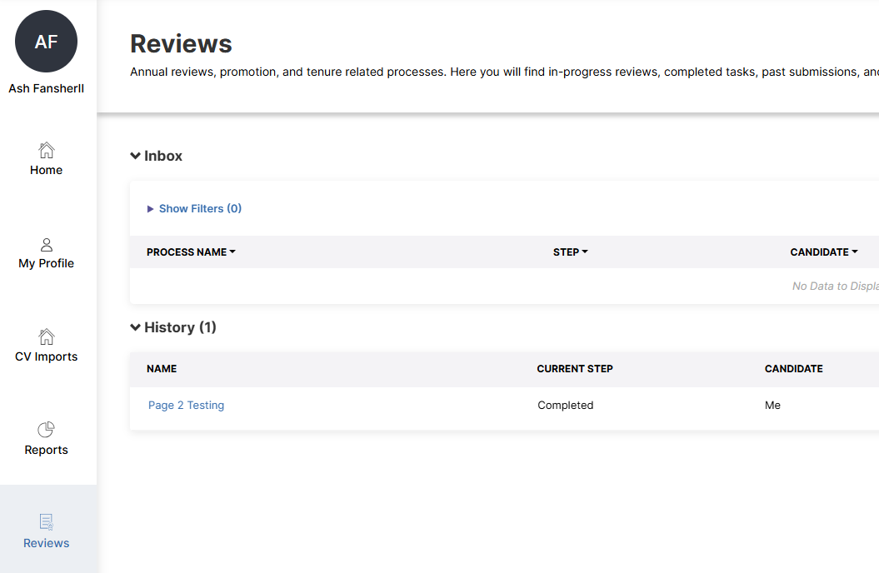

If your chair does not approve your Page 2, you will receive an email from Watermark to make changes.

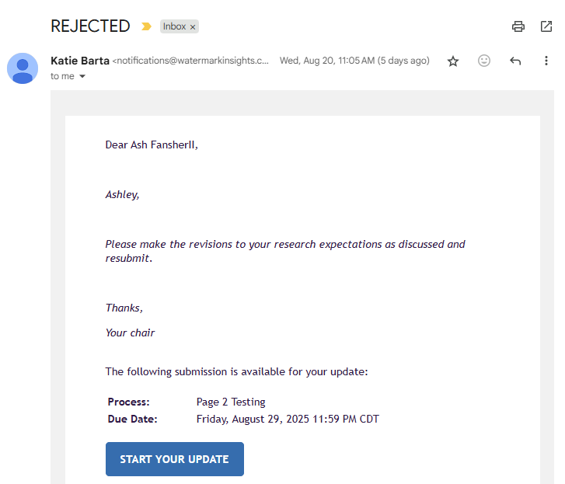

If your Page 2 is not approved, please discuss needed updates with your chair. Make changes by reentering the Page 2 through your Tasks & To-Dos. When finished, save, refresh the Page 2, review, and resubmit, using the steps above.

Any additional changes made after this approval process will need a separate workflow.

